

Electronics Lab #2  
Diode Characteristics and Circuits  
Hunter Dubel & Shubham Tandon  
ELC333-01  
Professor Ambrose Adegbege  
February 23rd, 2015

Content

Introduction 2

Theoretical Basis 3

Equations 3

List of Instruments Used 3

List of Materials Used 3

Circuits 3

Modeling Results 5

Experimental Measurements 7

Sample Calculations 8

Graphs 10

Conclusion 14

# Introduction

The target of this laboratory experiment is to observe and record the behavior of a zener diode, construct a voltage rectifier, low pass filter and voltage regulator. In order to understand the behavior of a zener diode we must understand that a zener diode is used to regulate voltage and avoid high voltage surges. A rectifier is an electrical device which alters alternating current (AC) to direct current (DC) the process of this conversion is called rectification. A low pass filter allows low frequency signals to pass and reduces the amplitude of frequencies higher than the cutoff frequency. A voltage regulator is an electrical device used to regulate voltage and keep it at a constant level.

# Theoretical Basis

## Equations

1. Current of the Diode:
2. Cutoff Frequency:
3. Capacitance:
4. Voltage Ripple:
5. Voltage Regulation:

## List of Instruments Used

Agilent Waveform Generator 33220A

LTSpice Software

Agilent DSO6012A Oscilloscope

Agilent Benchvue

## List of Materials Used

Breadboard

Circuit Board Wires

Resistors (1000 Ohms)

Capacitors (2.2 microFarad)

Zener Diodes (1N4733a)

## Macintosh SDD:Users:hunterdubel:Desktop:Screen Shot 2015-02-21 at 12.41.56 PM.png

# Experimental Measurements

**Part 1: Diode Characterization**

For this lab experiment we used a zener diode (1N4733A). We measured both the forward-bias and the reverse-bias resistance.

Refer to Table 2 of Sample Calculations

We then measured the voltage-current characteristic (forward-bias and reverse-bias) for a 1N4733A diode

Refer to Table 3 in Sample Calculations

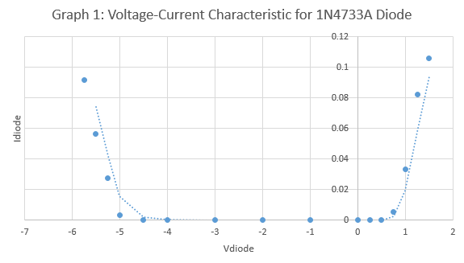

The Zener Voltage associated with 1N4733A is 5.1 nominal voltage

**Part 2: Diode Voltage Rectifier**

We designed a Diode voltage rectifier using four 1N4733A zener diodes and a 1kΩ resistor. A Voltage of 5Vpp and a frequency of 60Hz was the input.

**Figure 1:** Schematic of Diode Voltage Rectifier

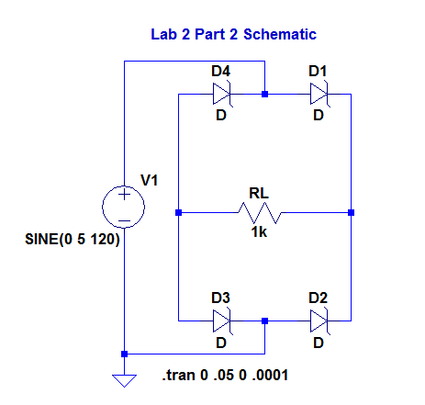

**Figure 2:** Simulation of Diode Voltage Rectifier

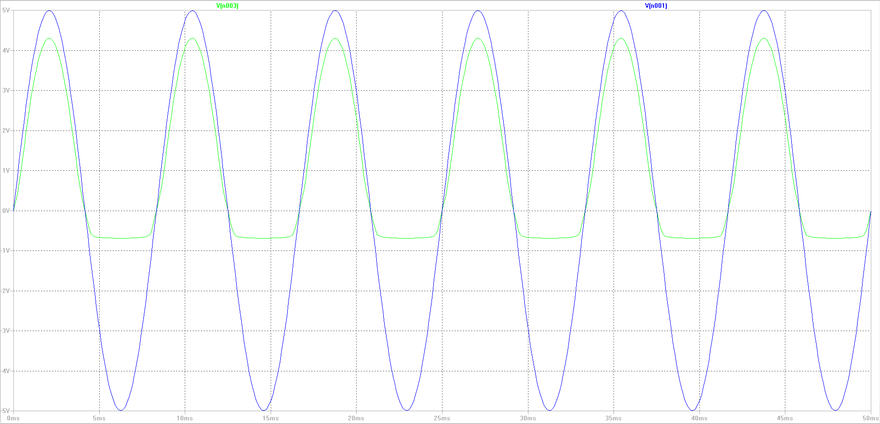

**Figure 3:** Hardware of Diode Voltage Rectifier

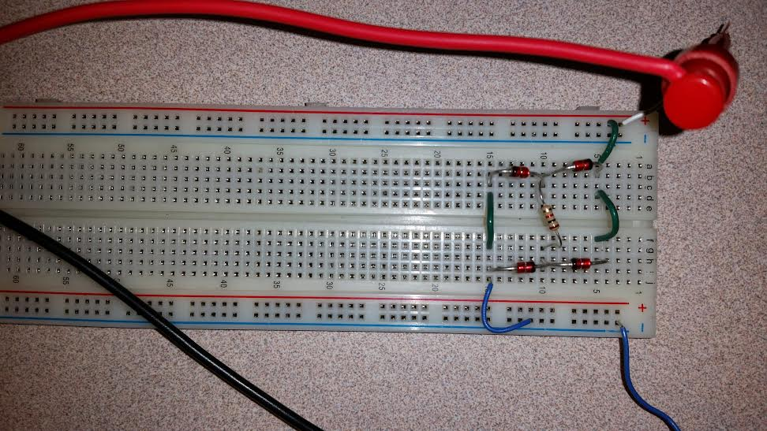

**Figure 4:** Screenshot of waveforms generated from the oscilloscope

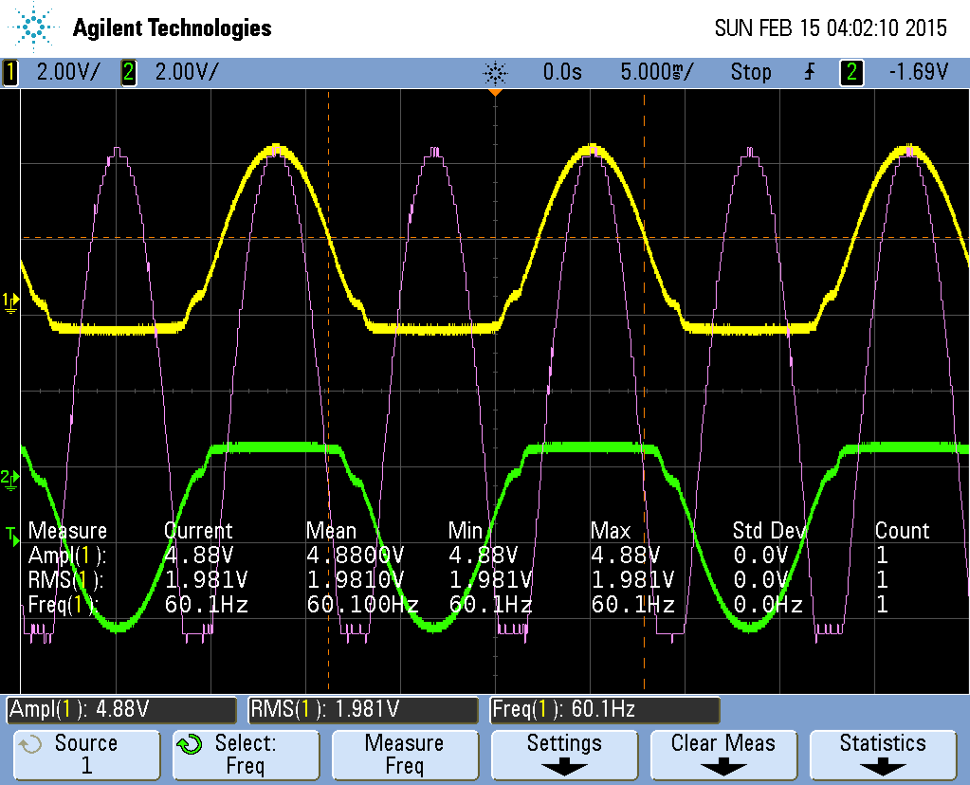

**(a)**

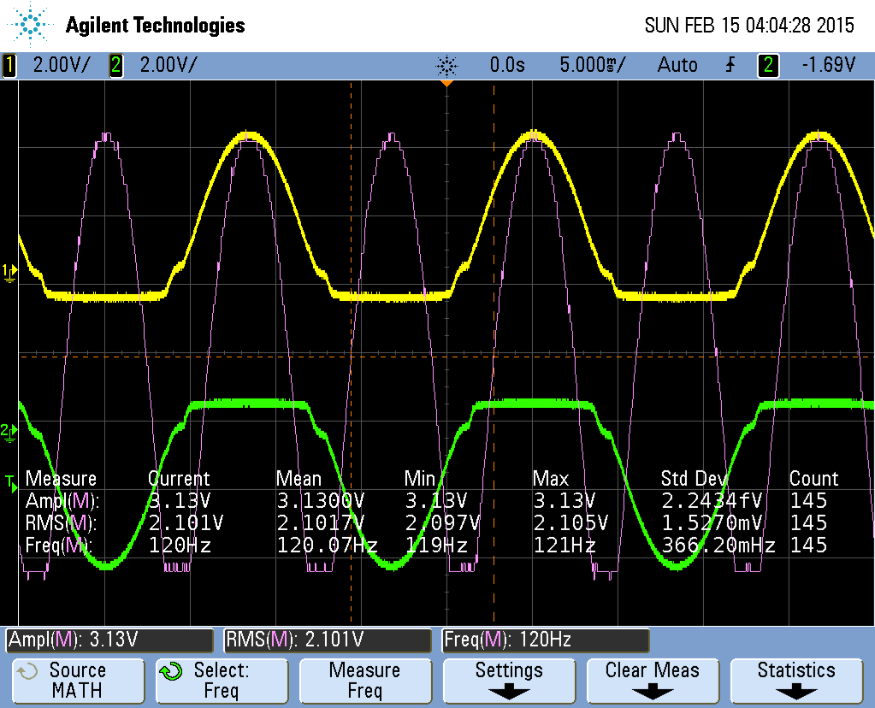

**(b)**

**Part 3: Low-Pass Filter**

We used Equation (2) to solve for the capacitance. Where fo=60Hz and R=1kΩ

We designed a Low-pass filter using four 1N4733A zener diodes, a 1kΩ resistor and a 2.2µF. A Voltage of 5Vpp and a frequency of 60Hz was the input.

**Figure 5:** Schematic of Low pass filter

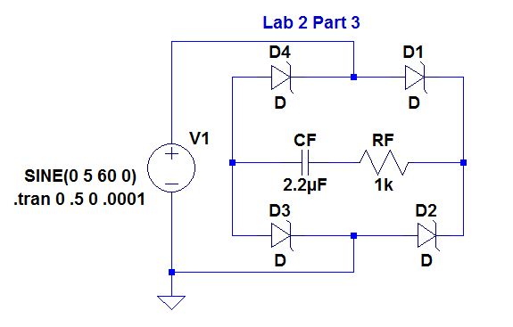

**Figure 6:** Simulation of Low pass filter

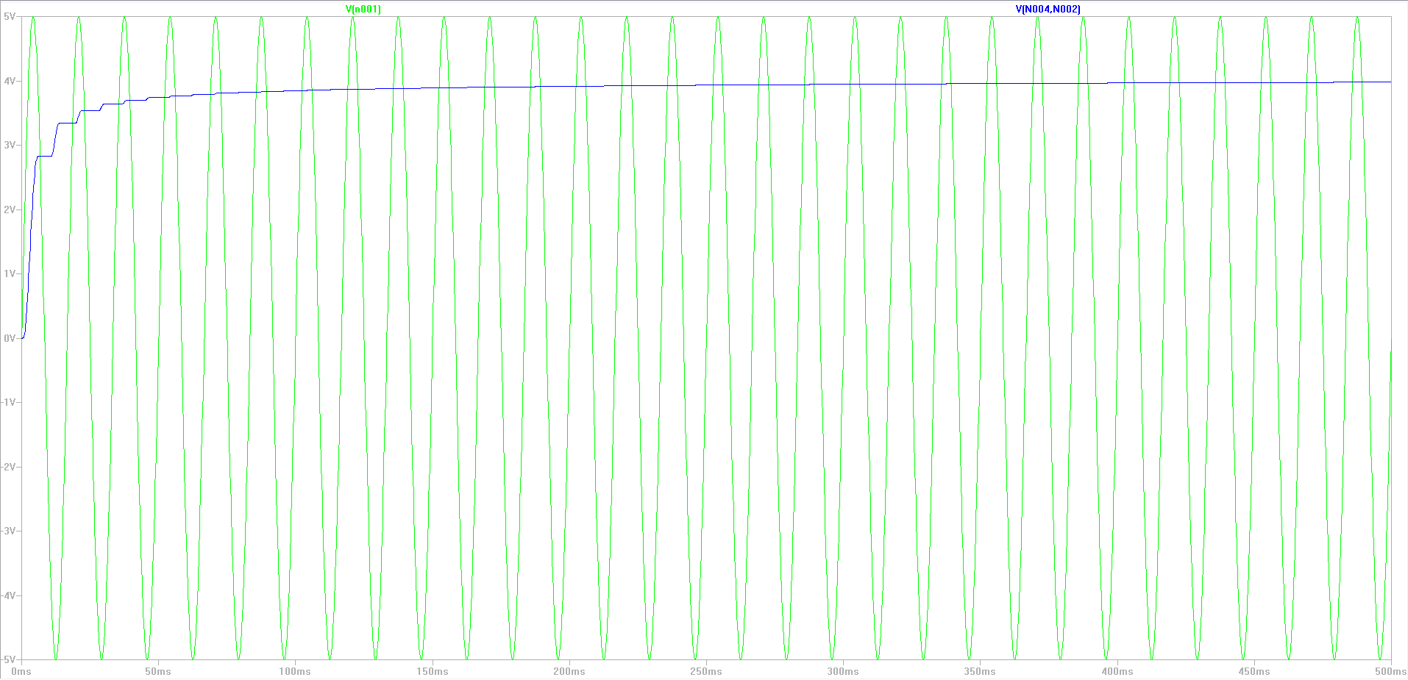

For the first 200ms the capacitor is charging up to reach its maximum voltage. This is due to the fact that the capacitor wasn’t at its maximum potential due to the fact that there was no current or voltage across the circuit. Therefore for the first 200ms the capacitor reaches its maximum potential.

**Figure 7:** Hardware of Low pass filter

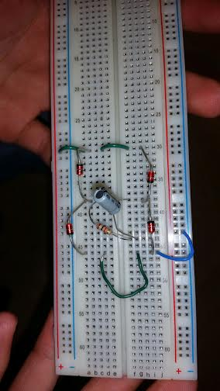

**Figure 8:** Screenshot of waveforms generated from the oscilloscope

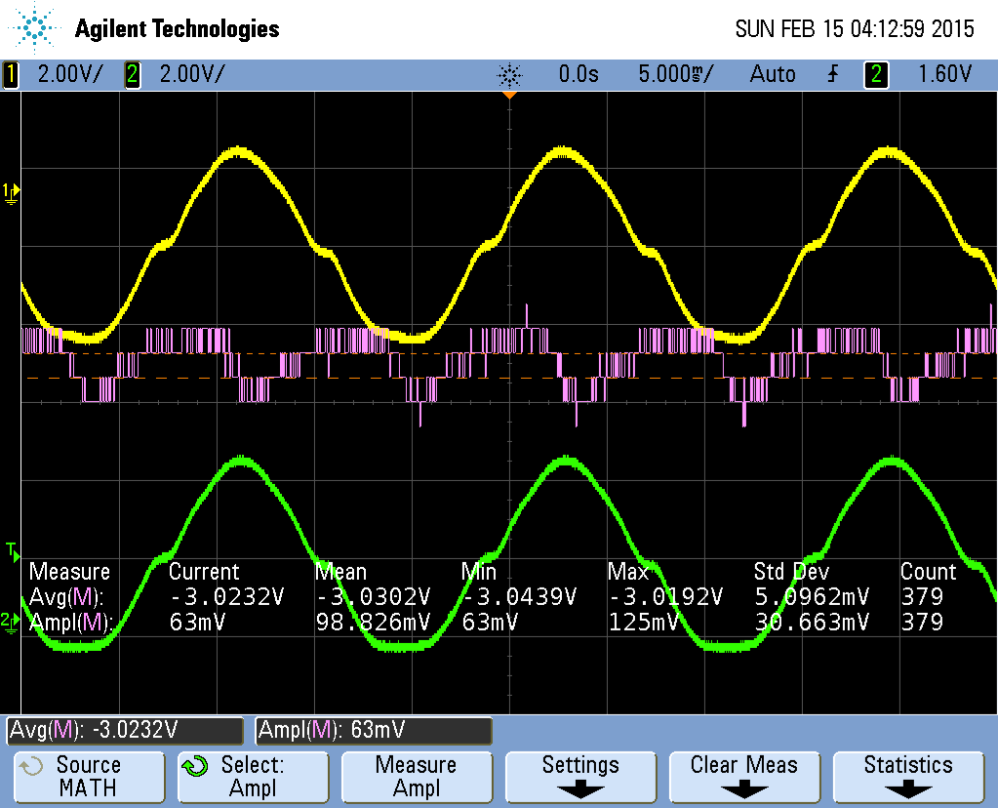

The average output voltage of this circuit in hardware is 3.0232V. This value is very close to our desired value of 2.8V. The error percentage is 7.97%

**Part 4: Diode Voltage Regulator**

We designed a diode voltage regulator using eight 1N4733A zener diodes, a 1kΩ resistor and a 2.2µF. A Voltage of 5Vpp and a frequency of 60Hz was the input. We wanted to regulate the voltage to 2.8V therefore we plugged in 4 diodes in parallel to the capacitor.

**Figure 9:** Hand drawn schematic of diode voltage regulator

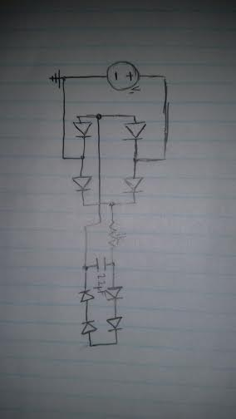

**Figure 10:** Schematic of diode voltage regulator

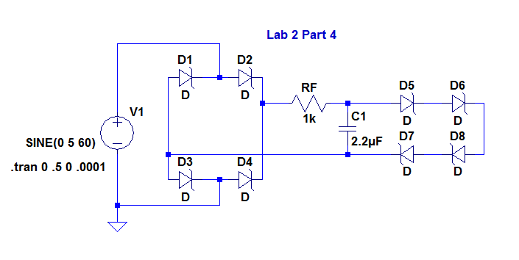

**Figure 11:** Simulation of diode voltage regulator

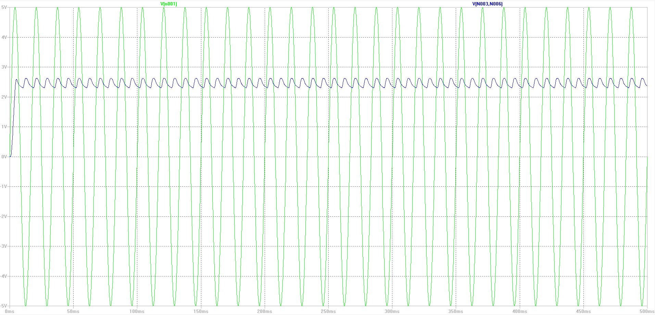

**Figure 12:** Hardware of diode voltage regulator

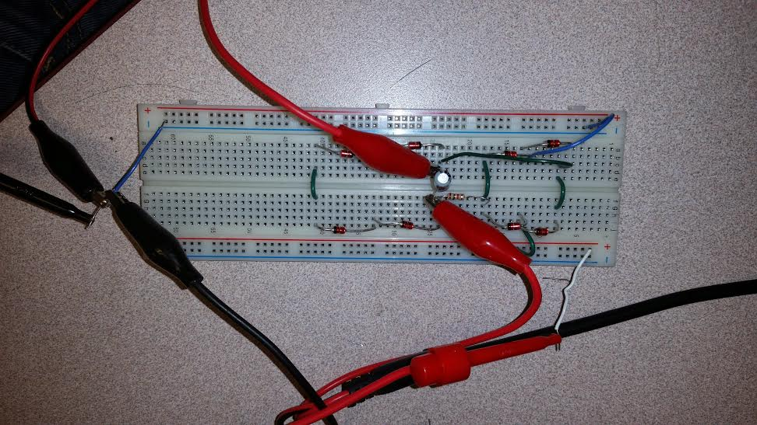

**Figure 13:** Screenshot of waveforms generated from the oscilloscope

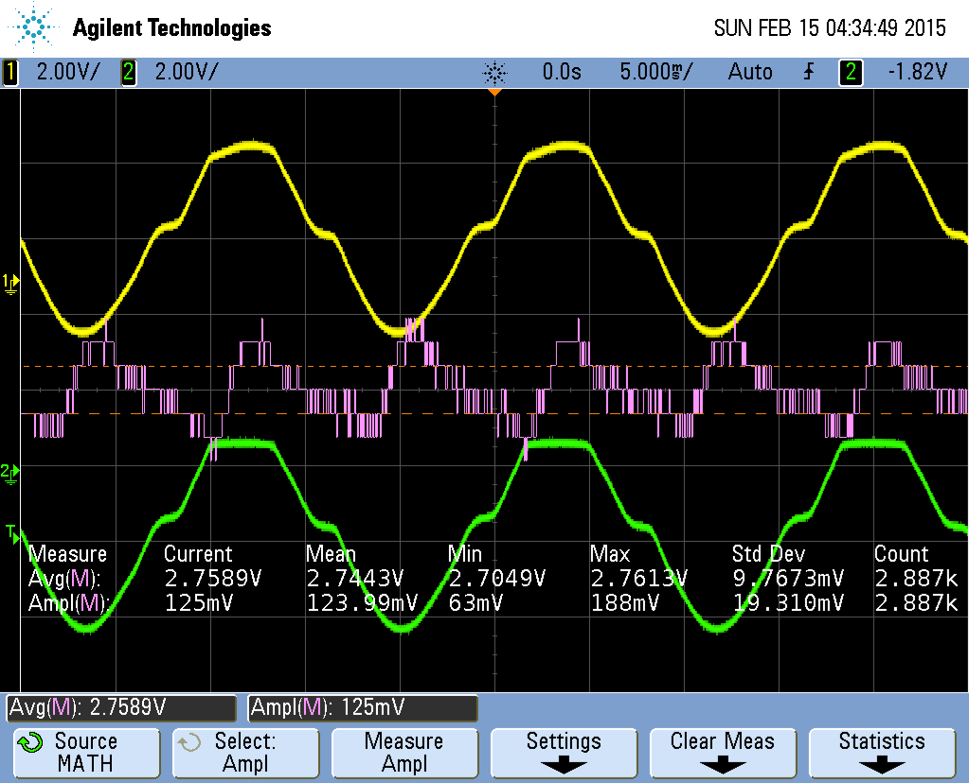

We regulated the voltage to 2.756V instead of the desired 2.8V. The percent error is 1.57%.

**Part 5: Load testing**

We plugged in different load resistances to the circuit. RL=10kΩ,5.1kΩ,1kΩ

**Figure 14:** Graph for 1kΩ

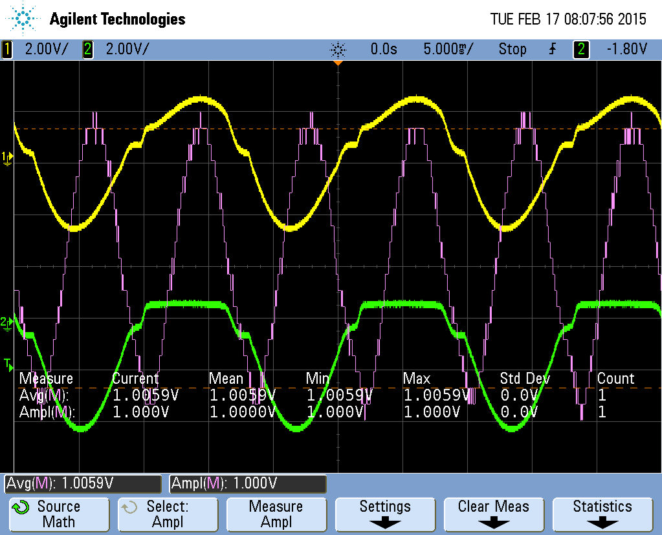

**Figure 15:** Graph for 4.7kΩ

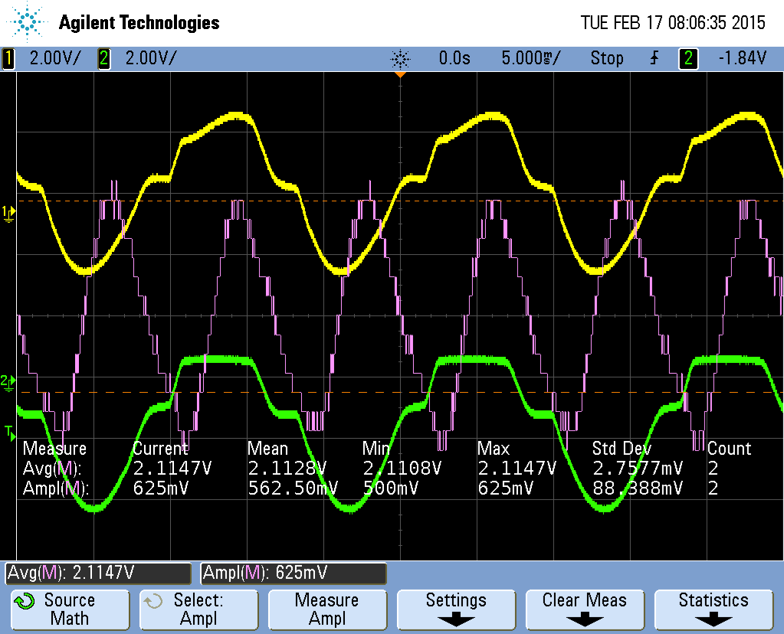

**Figure 16:** Graph for 10kΩ

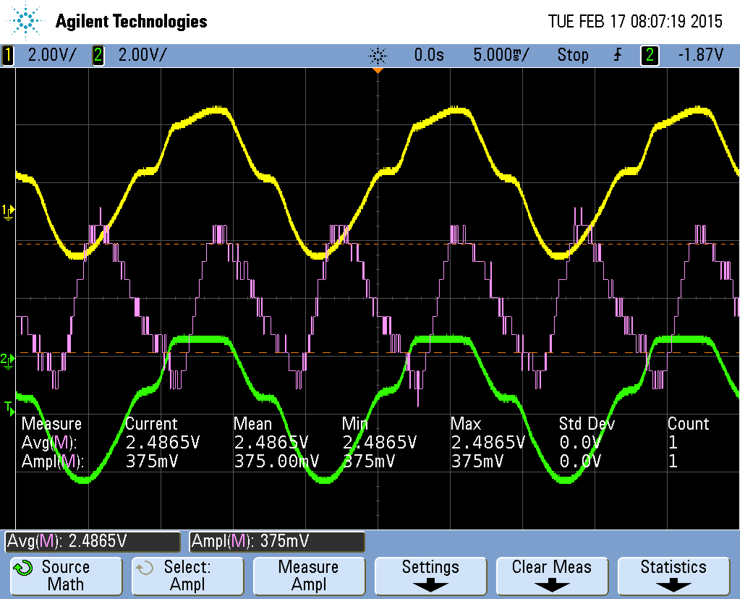

**Figure 17:** Graph for 51kΩ

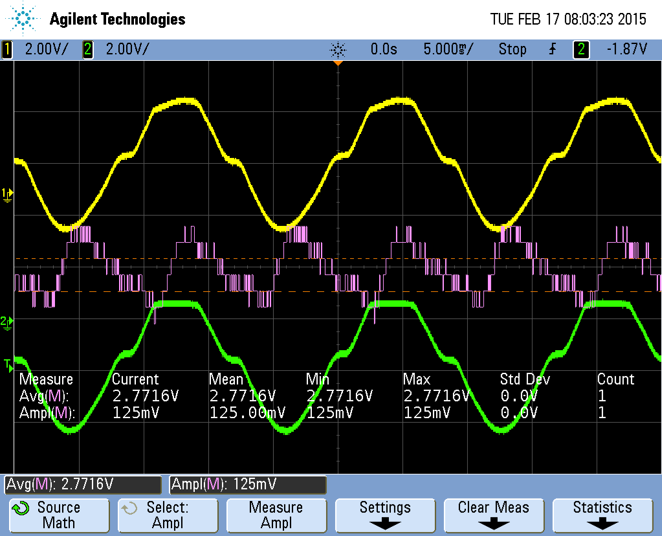

Plugging these values in (4) and (5) we get:

When RL=1kΩ; Vripple = 2.0118V; Voltage Regulation = 71.85%

When RL=4.7kΩ; Vripple= 4.2255V; Voltage Regulation = 150.91%

When RL = 10kΩ; Vripple = 4.973V; Voltage Regulation = 177.61%

When RL = 51kΩ; Vripple = 5.5432V; Voltage Regulation = 197.97%

The design should support an AC input with an amplitude of 50V. The diodes are made to regulate the voltage and maintain the capacitor’s voltage. The capacitor used also has a maximum value of voltage that is set at 63 Volts, above the value of 50V that would be applied.

# Sample Calculations

**Table 1: Values** The following are values of the resistor and capacitor used.  
*RL was given and CF was calculated using equation three.*

|  |  |
| --- | --- |
| Name | Resistance |
| RL | 1000 Ohms (Given) |
| CF | 2.2 microfarads |

**Table 2: Bias Values**

|  |  |
| --- | --- |
| Direction | Resistance (ohms) |
| forward-bias | 1.05MΩ |
| reverse-bias | 4.80MΩ |

**Table 3: Voltage Current**

|  |  |  |
| --- | --- | --- |
| Bias | Vdiode (V) | Idiode (A) |
| Reverse | -5.750 | 91.567mA |
| Reverse | -5.500 | 56.730mA |
| Reverse | -5.250 | 27.669mA |
| Reverse | -5.000 | 3.4079mA |
| Reverse | -4.500 | 0.3981mA |
| Reverse | -4.000 | 0.1045mA |
| Reverse | -3.000 | 0.0062mA |
| Reverse | -2.000 | 0.0002mA |
| Reverse | -1.000 | 0.0000mA |
| Forward | 0.000 | 0.0005mA |
| Forward | 0.250 | 0.0005mA |
| Forward | 0.500 | 0.0004mA |
| Forward | 0.750 | 5.2683mA |
| Forward | 1.000 | 33.559mA |
| Forward | 1.250 | 82.182mA |
| Forward | 1.500 | 105.96mA |

# Conclusion

There are many different types of diodes that can be utilized for varying purposes in electronics. This lab focused on the usage of the Zener diode to help regulate the amount of voltage that could be found in the circuit. Step two we turn out circuit into a rectifier by adding in a resistor in parallel to the diodes. The usage of a rectifier helped to convert the AC signals created by the waveform generator used as the input for the circuit into DC signals. In step three, a low pass filter is constructed by adding a capacitor in series with the resistor we added in step two. A low pass filter here helps by smoothening out the signal, removing any short fluctuations and only showing the long-term trend of the signal. Part four has four diodes in series added into parallel with the capacitor that we added into the circuit in the previous step. With the added diodes, the circuit becomes a voltage regulator and helps to maintain a constant voltage at 2.756 Volts. By becoming familiar with the components of a circuit and how adding on a resistor, a capacitor, and additional diodes we learn the relationship between a rectifier, a low-pass filter, and a voltage regulator. The only issue encountered during the lab was that the lab stock room did not have the proper values for the capacitor or the resistors needed. The value of capacitance solved for using equation 3 was about 2.6 microfarads. The closest value of the capacitor that could be obtained using the stock room supplies was 2.2 microfarads. One of the required values for the resistor in part five could not be found so instead of using a 5k-ohm resistor, a value of 5.1k ohm was used. These slight variances are what caused our values to be slightly off from their targeted goal but not far enough to skew the results out of tolerance.